Sri Lanka Institute of Information Technology



Assignment 1

<<Group Number>>

<<Project Title>>

2021

**Internet and Web Technologies – IT1100**

B.Sc. (Hons) in Information Technology

**Group Details**

Group Number:

Project Title:

|  |  |  |  |  |
| --- | --- | --- | --- | --- |
|  | **Student ID** | **Student Name** | **Email** | **Contact Number** |
| 1 | <<Leader’s Details>> |  |  |  |
| 2 |  |  |  |  |
| 3 |  |  |  |  |
| 4 |  |  |  |  |
| 5 |  |  |  |  |

# **Introduction**

<<Give a brief introduction about your project [350 words ]>>

# **2. Individual Contribution**

Member 01

Member 02

Member 04

Member 03

Member 05

# **Wire Frames**

* Home Page (EX )

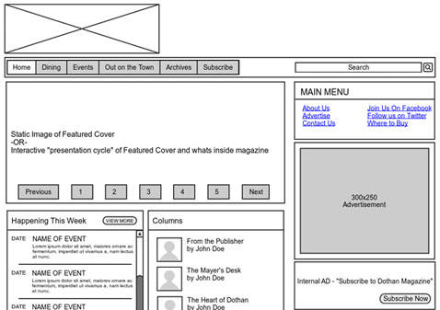

* Registration Page

* Login Page
* Contact Us Page
* User Account Page

* Category Display Page
* Product /Service page

**<<Note: Include wireframes for all the pages in your proposed web application. If you have identified more pages other than above pages, please include them as well. >>**

**<<IMPORTANT: Please upload the format of your document only by one person from the group >>**

*Official Use only: Filled by your Lecturers/Instructors*

**Marks for Project Proposals**

Acceptable: Mark/select as necessary

|  |  |  |
| --- | --- | --- |
| Acceptance/  Rejection | Correction State | |
| Minor Correction / Marks | Major Corrections |
| Accepted |  |  |
| Resubmit |  |  |
| Rejected |  | |

Corrections (if necessary)

Major changes proposed:

Any other Comments:

Supervisor Name:

Signature:

Date: